NYSSLS Daily Lesson Plan
Instructional Unit:  Weather and Climate –  Air masses, Fronts and Weather  LESSON: DENSITY |  |  |  |  |  | Period(s) of Unit:  1 PERIOD |  | Date:
Materials/Resources/Links:  Colorful Time-Lapse of Hot Air Balloons in New Mexico | Short Film Showcase (youtube.com)  Density‬ (colorado.edu) |  |  |  |  |  |  |  | Course:  Earth and Space Science
Special Notes for Lesson:

ANCHORING PHENOMINON: Why do hot air balloons fly?

Standards:
Science and Engineering Practices  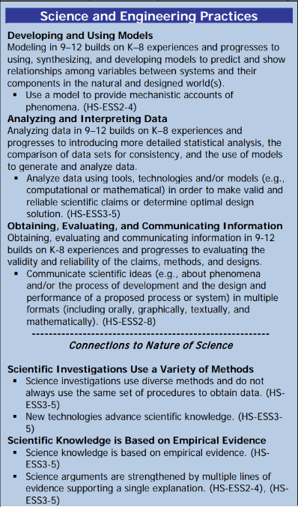 |  |  | Disciplinary Core Idea(s)  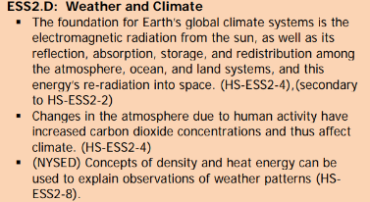 |  |  |  | Cross Cutting Concepts  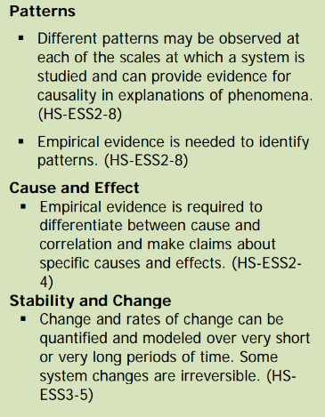
Performance Level
NYS Level 5 | NYS Level 4 |  |  | NYS Level 3 | NYS Level 2 |  |  | NYS Level 1
Collect and analyze global and regional weather data using tools, technologies, and /or models to communicate in multiple formats how the movement and interactions of airmasses result in changes in weather conditions. | Evaluate data and communicate information to explain hoe the movement and interactions of air masses result in changes in weather conditions |  |  | Evaluate data and communicate information to identify patterns of movement and/or the resulting changes in weather conditions. | Use data to identify the patterns of movement or the interactions of air masses and the resulting change in weather conditions  or to identify factors that drive the movement of air masses or from given weather conditions, identify evidence from maps that support these conditions. |  |  | Use data and/or patterns of movement and interactions of air masses to identify the resulting changes in weather conditions or identify one factor that drives the movement of air masses or from those provided, use evidence from maps to account for weather conditions or given weather conditions, identify evidence found on maps that account for one of these conditions.
Clarification Statement  Examples of evidence sources could include station models, surface weather maps, satellite images, radar and accepted forecast models. Emphasis should focus on communicating how the uneven heating of the Earth’s surface at frontal boundaries and resulting weather phenomena. |  |  |  |  | Assessment Boundary  Analysis is limited to surface weather maps and general weather patterns associated with High and Low pressure systems
Connection to Anchoring Phenomenon:

All weather is caused by density differences in the air that causes air to rise or sink. These Density differences are caused by uneven heating of the Earth by the sun.

Essential Question(s):
What is inside a hot air balloon?

What surrounds the hot air balloon?

What makes the hot air ballon rise?

Instructional Strategies & Learning Tasks: Engage, Explore, Explain, Elaborate, Evaluate
Engage: images, video clip or data… |  | A picture or video of a hot air balloon will be shown.
Explore: Students investigate, experiment, hands-on activity…. |  | Using the density simulation students will investigate why some blocks float in water and why some sink. Students will work in groups to reason why this is happening.
Explain: Students share their observations and evidence to explain their understanding…possible whole group/class discussion… |  | Students will present their reasoning to the class as to why some blocks sink and float.
Elaborate: Students apply the science concepts they’ve just learned… |  | Students will be presented with 2 different air masses, one hot and one cold. They will predict what will happen when these air masses come in contact.
Evaluate (Formative Assessment): Student learning is evaluated. |  | Students will be evaluated by their answers to teachers questions They will eventually be evaluated by a test or a quiz.

Copy and paste student worksheets below:

